Distributed and Cloud Computing

ASSIGNMENT 1

1. RPC

I have implemented an RPC application for generating Pascal’s triangle using the RPCGEN Protocol Compiler. It helps the programmers to write RPC applications simply and directly. It does most of the dirty work, allowing programmers to debug the main features of their application. RPCGEN is a compiler. It accepts a remote program interface definition written in a language, called RPC Language, which is similar to C.

1. INSTALLATION of RPCGEN using the command given in the image

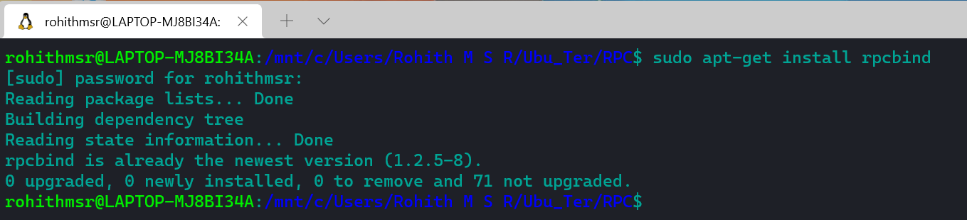

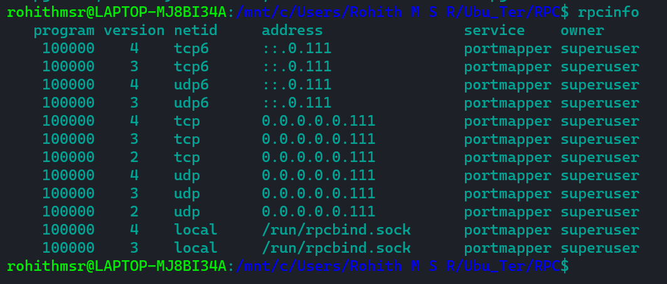

1. Define the interface

Create an interface file (*file-name.x*) which will act as an interface between the caller and the host. Here we will declare our function which will be executing in the host and would be called by the client. ‘0x20020020’ is the address space where our host is going to execute. Structure S is the input we pass from the client.

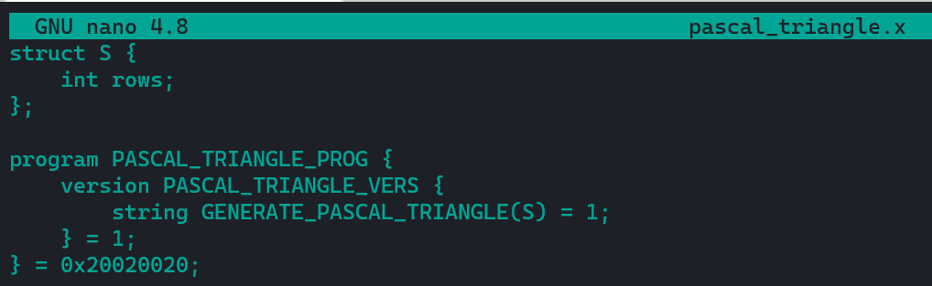

1. Generate the client and server files as well as the *Makefile* by compiling the interface file (-a for Makefile, -C for otherfiles). Once the command is run, you can see some new files have been generated.

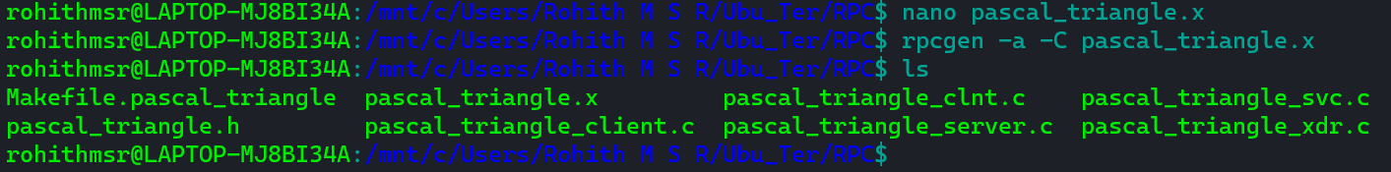

1. Add your code to the client and the host files

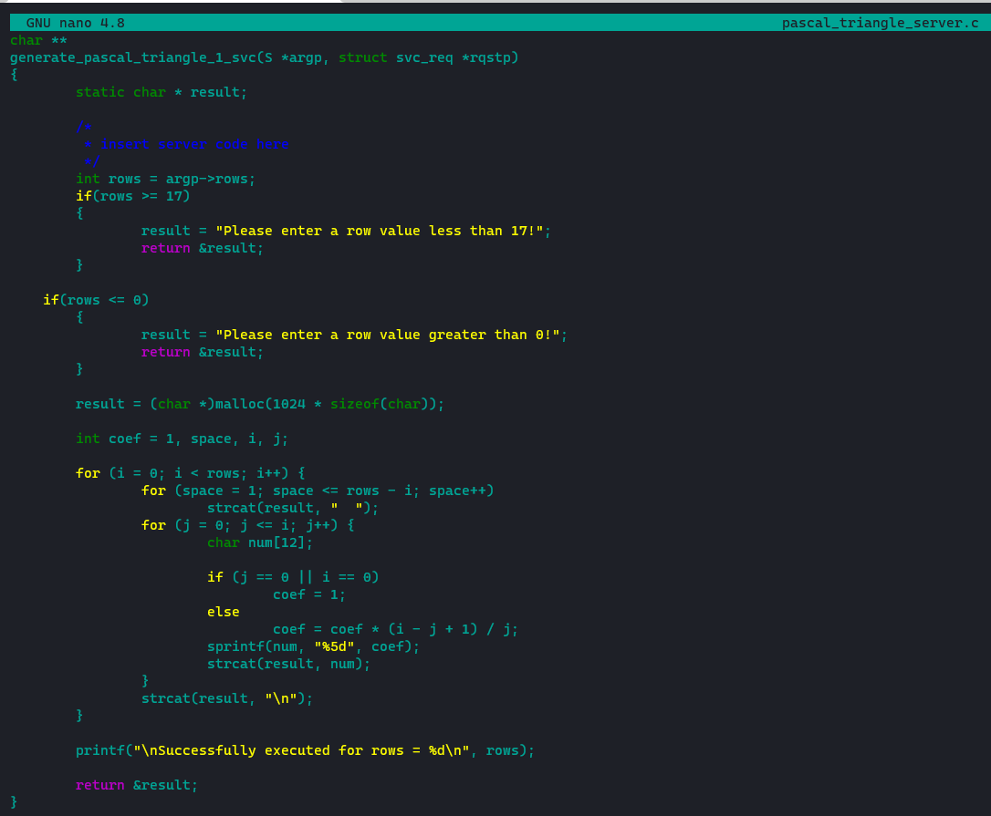

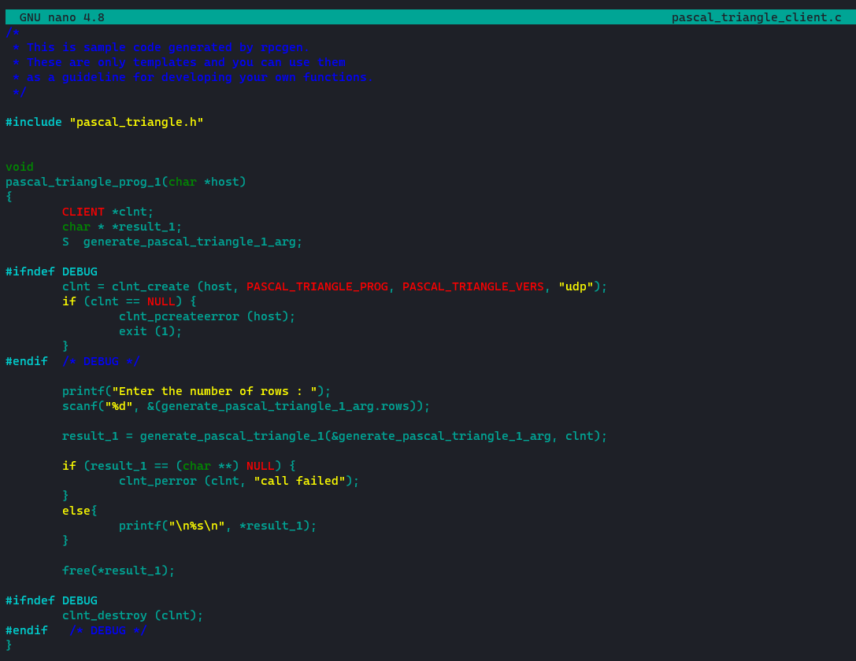

1. Compile all the files

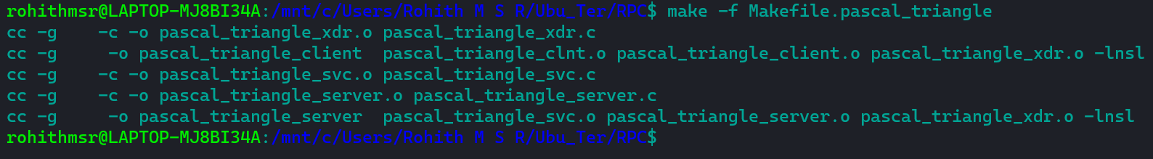

1. Run the host and the client programs

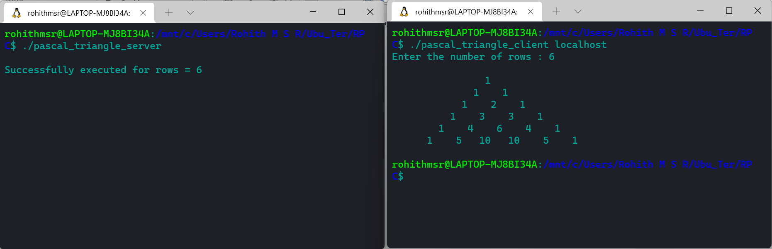

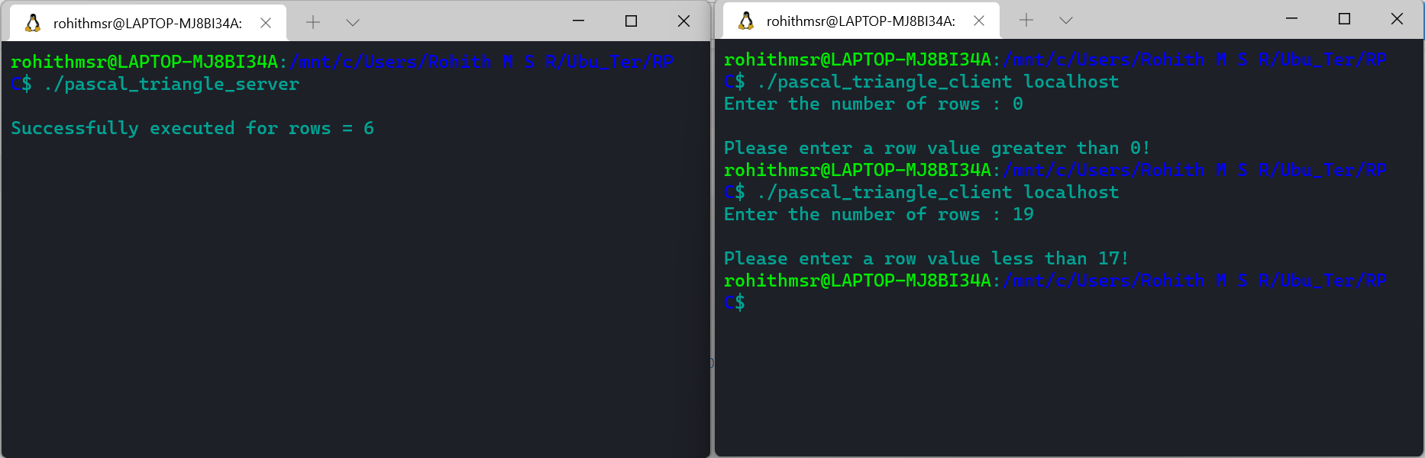

1. TORRENT

Create and Distribute a Torrent file to share a file in a LAN Environment.

TERMINOLOGIES:

**SEEDERS** = People who have the entire torrent file on their computer are referred to as seeders. Having downloaded the file already, these users are uploading pieces of the file to help other users download it.

**SHARE RATIO** = Share Ratio is the amount of data you have downloaded for a torrent share divided by the amount of data that you have uploaded. A ratio of less than 1 means that you have mostly downloaded and stopped the torrent after finishing. Ratio of more than 1 denotes that peer is a good peer.

**TRACKERS** = A torrent tracker is a server that tracks torrent users and keeps the information such as

the number of seeders and leechers

the torrent file size and number of downloads.

Without trackers, you would not be able to start your downloads. It means that your torrent will be stuck at 0% because it cannot find any seeds or peers. If you add a torrent to your torrent program by downloading a .torrent file or clicking a magnet link, it will already contain a reference to 1 or a small list of trackers. By adding trackers, your downloads will not get stuck at zero percent and your overall downloads speed will increase, so that in the end your downloads will finish quickly.

1. INSTALLATION

Install qBittorrent, an open-source alternative to µTorrent. You can download this BitTorrent client from <https://www.qbittorrent.org/download.php/>

1. CREATION OF TORRENT FILE
2. Click Tools->Torrent Creator

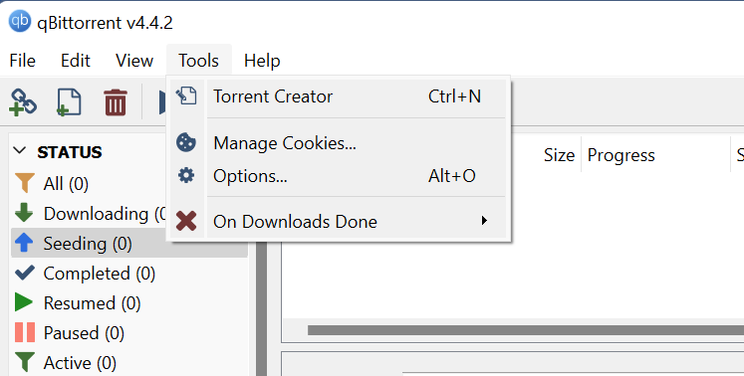

1. Select the **.mp4** file you want to share

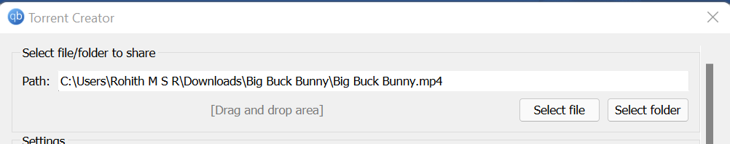

1. Select the chunks’ size as 4MiB [55 chunks for this file]

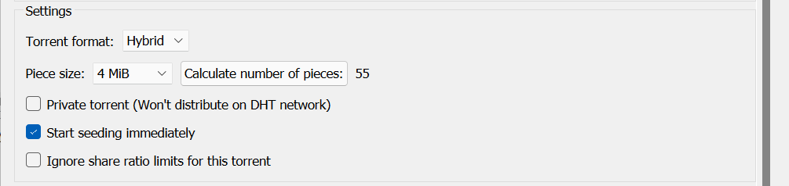

1. Add some of the public trackers for my torrent file

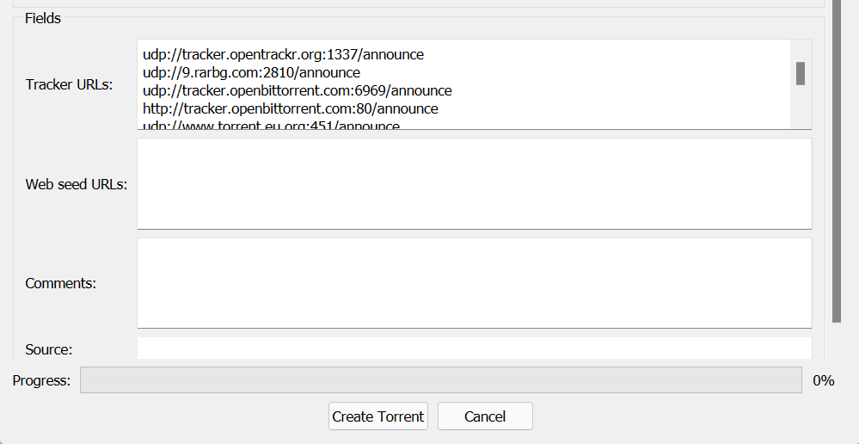

1. Click create torrent and start seeding the file

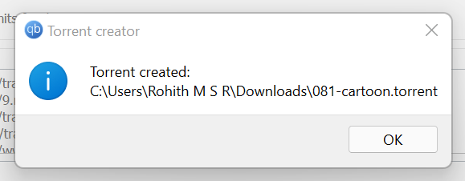

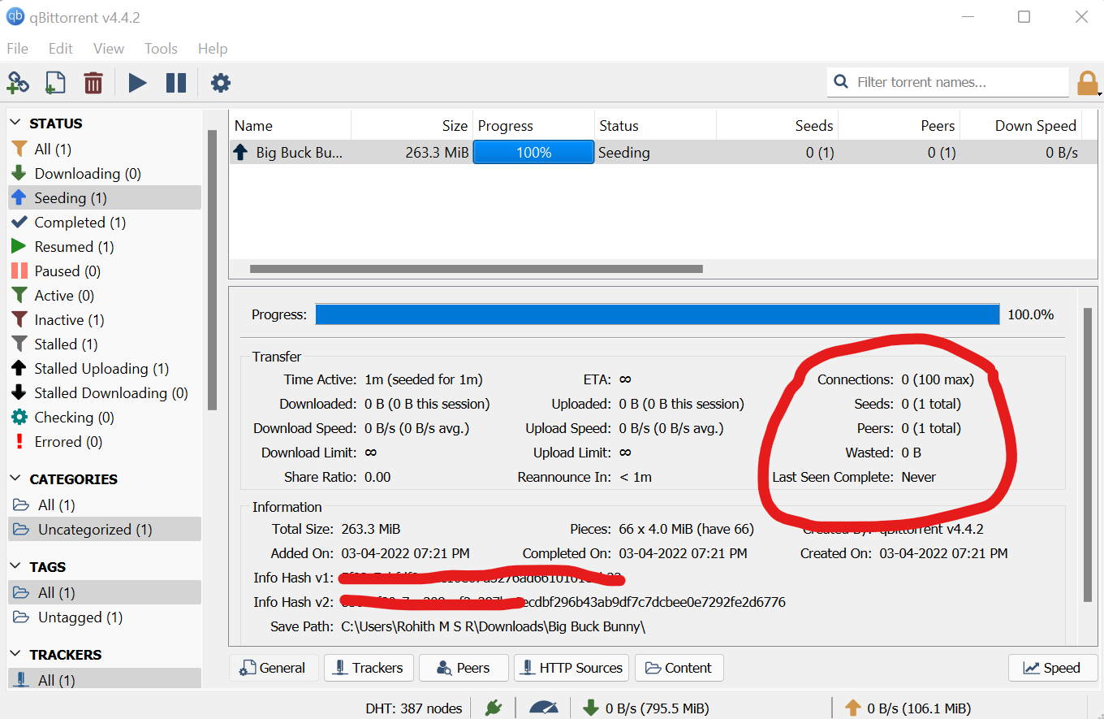

1. SHARE THE TORRENT FILE TO OTHER SYSTEMS.

Shared the torrent file to my mobile

* FILE STARTS DOWNLOADING

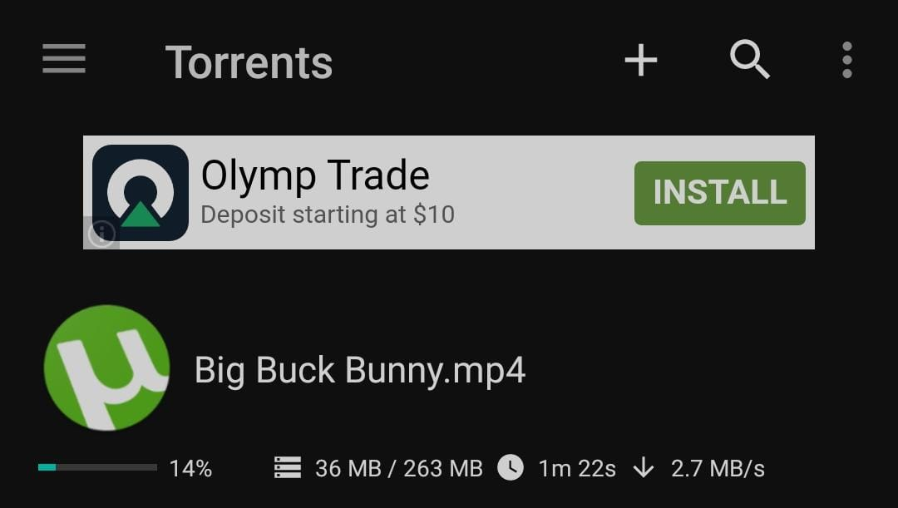

* PAUSE SEEDING, FILE DOWNLOADING DELAY IS REFLECTED ON MY PHONE [Shows **6 weeks 3 days to download**]

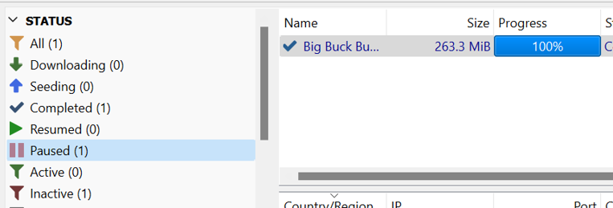

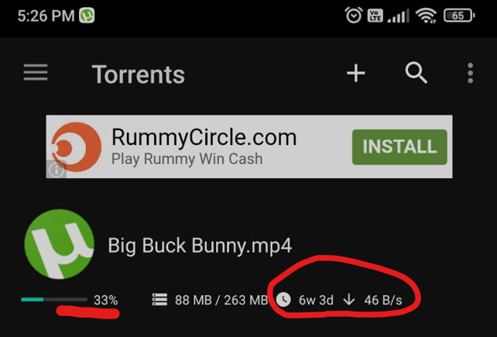

* ONCE AGAIN, RESUME SEEDING IN MY LAPTOP, DOWNLOAD BEGINS

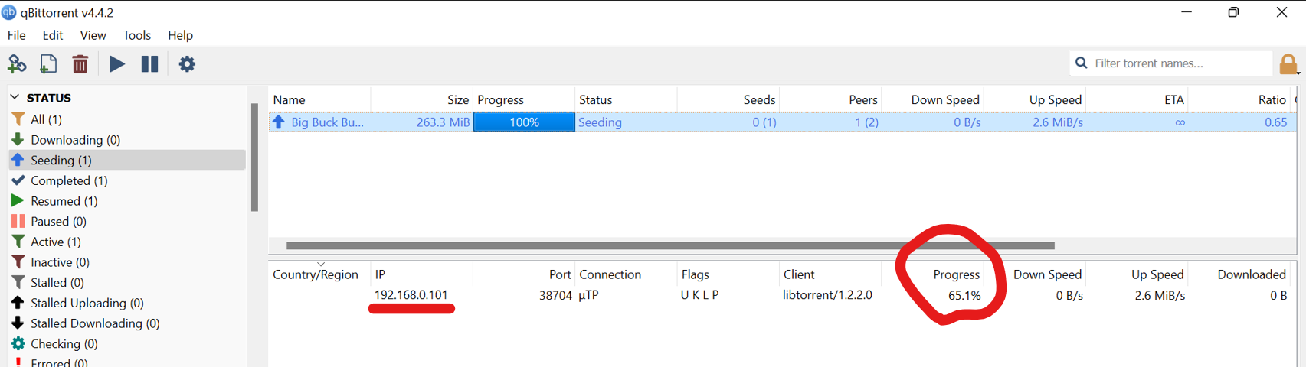

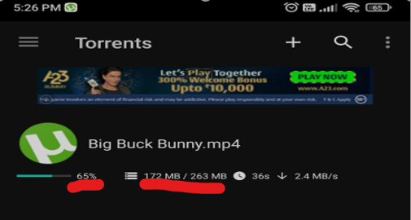

* DOWNLOADED SUCCESSFULLY !

